

**BROOKLYN**

**PS 240K/Andries – Opens 7/6**

Mon, Wed, Fri: 1-4pm

2500 Nostrand Avenue

Brooklyn, NY 11210

Site Director: Bob Spigner

CM Williams (45)

**PS 203K – Opens 7/6**

Tuesday & Thursday, 1-4pm

5101 Avenue M

Brooklyn, NY 11234

Site Director: Bob Spigner

CM Maisel (46)

**McDonald Park – Opens 7/5**

Monday – Friday: 9am-1pm

McDonald Ave btwn Ave S & T,

Brooklyn, NY 11223  
Site Director: Gennadiy Shuminov

CM Treyger (47)

**BROOKLYN**

**PS 9K – (Opens 7/30 or 8/6)**  
Monday-Friday: 9am-12pm

80 Underhill Avenue

Brooklyn, NY 11238  
Site Director: Bob Spigner

CM Cumbo (35)

**Sperandeo Park – Opens 7/5**

Monday – Friday: 9am-2pm

Cleveland St. btwn Atlantic & Liberty

Brooklyn, NY 11208  
Site Director: Jackie Babb

CM Espinal (37)

**PS 172K – Opens 7/5; Closes 7/27**

**STUDENTS OF PS 172K ONLY**

Monday – Thursday: 9am-12pm

825 4th Avenue, Brooklyn, NY 11232

Site Director: Bob Spigner

CM Menchaca (38)

**PS 249K – Opens 7/6**  
Monday, Wednesday, Friday: 2-5pm

18 Marlborough Road   
Brooklyn, NY 11226

Site Director: Gennadiy Shuminov

CM Eugene (40)

**Linden Park – Opens 7/5**  
Monday – Friday 9am-1pm

Vermont St. & Stanley Avenue

Brooklyn, NY 11207

Site Director: Hector Henry

CM Barron (42)

**PS 229 – Opens 7/5**  
Monday – Thursday: 8am-11am

14th Ave. btwn Benson & Bath

Brooklyn, NY 11228

Site Director: Kareem King

CM Brannan (43)

**QUEENS**

**Bayswater Park – Opens 7/5**

Monday – Friday: 9am-12pm

Bay 32nd St & Beach Channel Dr.

Queens, NY 11691

Site Director: Julian Morales

CM Richards (31)

**Charles Park – Opens 7/5**

Monday – Friday: 9am-12pm

98-01 165th Avenue

Howard Beach, NY 11414

Site Director: Richard Jaklitsch

CM Ulrich (32)

**QUEENS**

**Jamaica HS – Opens TBD**

Mon, Wed, Fri, 1pm-4pm

84th Avenue & 168th Street   
Jamaica, NY 11432

Site Director: Zachary Breland

CM Lancman (24)

**Newtown HS – Opens 7/5**

Monday – Friday: 9am-1pm

90th Street & 57th Ave,   
Elmhurst, NY 11373

Site Director: Gaetan Georges

CM Dromm (25)

**IS 204Q – Opens 7/5**    
Monday – Friday: 9am-2pm

36-41 28th St, LIC, NY 11106

Site Director: Victor Santamaria

CM Van Bramer (26)

**Det. Keith Williams – Opens 7/5**

Monday-Friday, 9am-12pm

173rd St & Liberty Ave

Jamaica, NY 11433

Site Director: Zachary Breland

CM Miller (27)

**PS 223Q – Opens 7/5**

Tuesday & Thursday: 1-4pm

125-20 Sutphin Blvd,   
Jamaica, NY 11434

Site Director: Jean Lou Supplice

CM Adams (28)

**JHS 190Q – Opens 7/5**

Monday – Friday: 9am-1pm

68-17 Austin St,

Forest Hills, NY 11375

Site Director: Jean Lou Supplice

CM Koslowitz (29)

**QUEENS (12)**

**JHS 194Q – Opens 7/5**

Monday – Friday: 9am-1pm

154-60 17th Ave, Whitestone, NY 11357  
Site Director: Jerry Tucker

CM Vallone (19)

**Bay Terrace – Opens TBD**

Days & Times, TBD

212-00 23rd Ave, Bayside, NY 11360  
Site Director: TBD

CM Vallone (19)

**Leavitt Field – Opens TBD**

Tuesdays & Thursdays, 2-5pm

Leavitt St. & 34th Road

Flushing, NY 11354

Site Director: TBD

CM Koo (20)

**IS 10Q – Opens 7/6**  
Monday - Friday: 9am-12pm

45-11 31st Avenue, Queens, NY 11103

Site Director: Tom O’Kelly

CM Constantinides (22)

**PS 122Q – Opens 7/6**

Mon, Wed, Fri: 1-4pm

21-21 Ditmars Blvd., Astoria, NY 11105

Site Director: Tom O’Kelly

CM Constantinides (22)

**PS 205Q – Opens 7/5**

Monday – Friday: 9am - 2pm

75-25 Bell Blvd, Bayside, NY 11364  
Site Director: Christian Georges

CM Grodenchik (23)

**MS 172Q – Opens TBD - Fall**

Days & Times, TBD

81-14 257th Street, Glen Oaks, NY 11004  
Site Director: TBD

CM Grodenchik (23)

**Free Community Tennis Program – Summer 2018 *Subject to Change* #6 7/11/18**

**STATEN ISLAND (3)**

**Silver Lake – Opens 7/6**

Mon,Wed, Fri: 1:30-4:30pm  
42 Revere St,

Staten Island, NY 10301

Site Director: Mike Akinola

CM Rose (49)

**IS 2 – Opens 7/6**

Mon,Wed, Fri: 9am -12pm  
333 Midland Avenue

Staten Island, NY 10306  
Site Director: Mike Akinola

CM Matteo (50)

**Wolfe’s Pond – Opens TBD**Tuesday & Thursday, 9am-1pm100 Luten Avenue

Staten Island, NY 10312  
Site Director: Mike Akinola

CM Borelli (51)

Most Sites are generally open for 3 hours or more per session. Scheduled lessons are usually 1-1.5 hours.  
 Any participant, age 11 and over, depending on his/her ability to occupy themselves while unsupervised by NYJTL staff, is welcome to come outside the scheduled lesson time.   
Such kids are free to play depending on availability of any court where lessons are not be conducted.

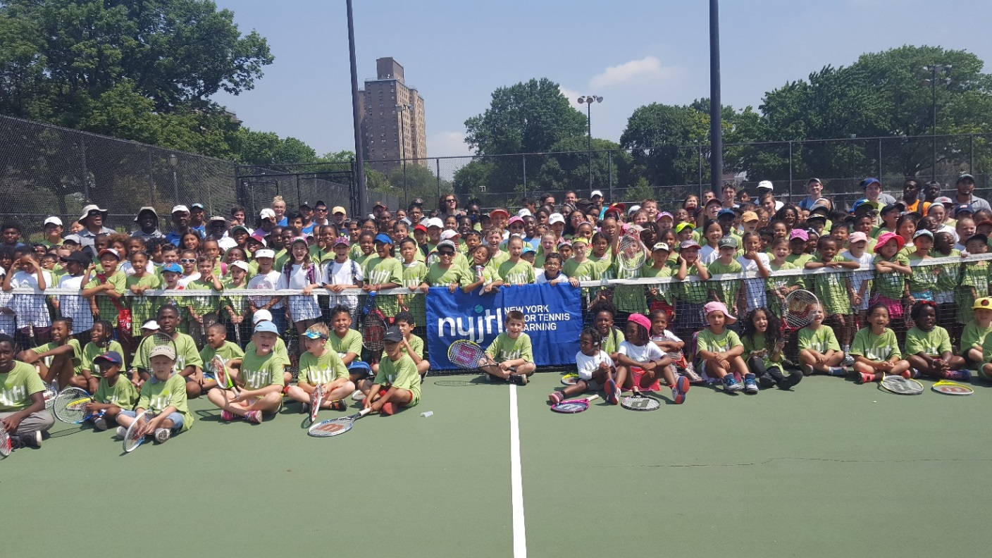  


Most Sites are generally open for 3 hours or more per session. Scheduled lessons are usually 1-1.5 hours.  
 Any participant, age 11 and over, depending on his/her ability to occupy themselves while unsupervised by NYJTL staff, is welcome to come outside the scheduled lesson time.   
Such kids are free to play depending on availability of any court where lessons are not be conducted.

**Tentative Summer 2018 Locations**

**All Sites/Times Subject to Change**

NYJTL's FREE Summer Tennis programs will start at most locations on July 5, 2018. Days and times vary by site. Please check your preferred site to get exact details.

For all NYJTL Community Tennis Programs, registration is OPEN. Players can register at any time during the season. Registration is completed in person ONLY during the program’s hours of operation.   
No online registrations. A reminder that this is not an application, it is a registration. So no one will be rejected or put on a waiting list. Attendance on any given day is optional.

Visit our website us at [www.nyjtl.org](http://www.nyjtl.org)/programs/free-tennis for program updates and news.

For additional information contact: [tc@nyjtl.org](mailto:tc@nyjtl.org) or   
call Alejandra at 347-417-8125/ Angela at 347-417-8153

**BRONX (6)**

**JFK Campus – Delayed Opening**

Monday, Wednesday & Friday: 1-4pm

99 Terrace View Avenue

Site Director: Lorraine Rohlsen

CM Rodriguez (10)

**Co-op City – Opens 7/5**

Monday – Friday: 9am-12pm

Donizetti Place, Bronx, NY 10475

Site Director: Lorraine Rohlsen

CM King (12)

**PS 83X – Opens 7/5**Tuesday & Thursday: 9am-12pm

950 Rhinelander Avenue

Bronx, NY 10462

Site Director: Dudley Gayle

CM Gjonaj (13)

**Crotona Park – Opens 7/5**

Monday – Friday: 9am-2pm

1700 Crotona Ave, Bronx, NY 10457

Site Director: Eugene Bantovsky

3 CMs (Gibson, Torres, Salamanca)

**St. James Park – Closed due to construction as of 7/9/18**

Mon, Wed, Fri: 1-4pm

Jerome Ave, E. 193 St, Creston Ave Bronx, NY 10468

Site Director: Dudley Gayle

CM Cabrera (14)

**BIYTC – Opens 7/5**

Monday – Friday: 9am-2pm  
754 Thieriot Ave, Bronx, NY 10473

Site Director: Alberto Luna

CM Diaz, Sr. (18)

**MANHATTAN**

**Brandeis/McCourt – 7/9**

Mon, Wed, Fri: 1-4pm

145 W 84th Street

New York, NY 10024

Site Director: Jake Laurence

CM Rosenthal (6)

**PS 125M – Opens 7/5**

Monday-Thursday: 9am-12pm

425 West 123rd Street

New York, NY 10027

Site Director: Marlene Charles

CM Levine (7)

**Randall’s Island –   
Opens 7/8 to 8/5**

Saturdays 1pm-4pm

1 Randall’s Island, NY, NY 10035

Site Director: Ofir Solomon

CM Ayala (8)

**PS 187M – Opens 7/6**

Mon, Wed, Fri: 9am-12pm

349 Cabrini Boulevard

New York, NY 10033

Site Director: Willie Green

CM Rodriguez (10)

**MANHATTAN (9)**

**Seward Park – Opens 7/5**

Monday-Friday 9am-12pm

Essex St & Hester St,

New York, NY 10002

Site Director: Theodore Small

CM Chin (1)

**JHS 104M – Opens 7/5**

Tuesday – Thursday: 9am-12pm

330 East 21st Street

New York, NY 10010

Site Director: Evelyn David

CM Rivera (2)

**Manhattan Plaza – Opens 7/6**

Tuesday & Thursday: 1pm-3pm

450 West 43rd Street

New York, NY 10036

Site Director: Jake Laurence

CM Johnson (3)

**JHS 167M – Opens 7/5**

Monday – Friday: 9-2pm

220 E76th Street,   
New York, NY 10021

Site Director: Ron Simmons

CM Powers (4)

**Octagon Park – Opens 7/5**

Monday – Friday: 1-4pm

Main St (North End),   
Roosevelt Island, NY 10044

Site Director: Joyce Short

CM Kallos (5)

**Free Community Tennis Program – Summer 2018 *Subject to Change* #6 7/11/2018**