

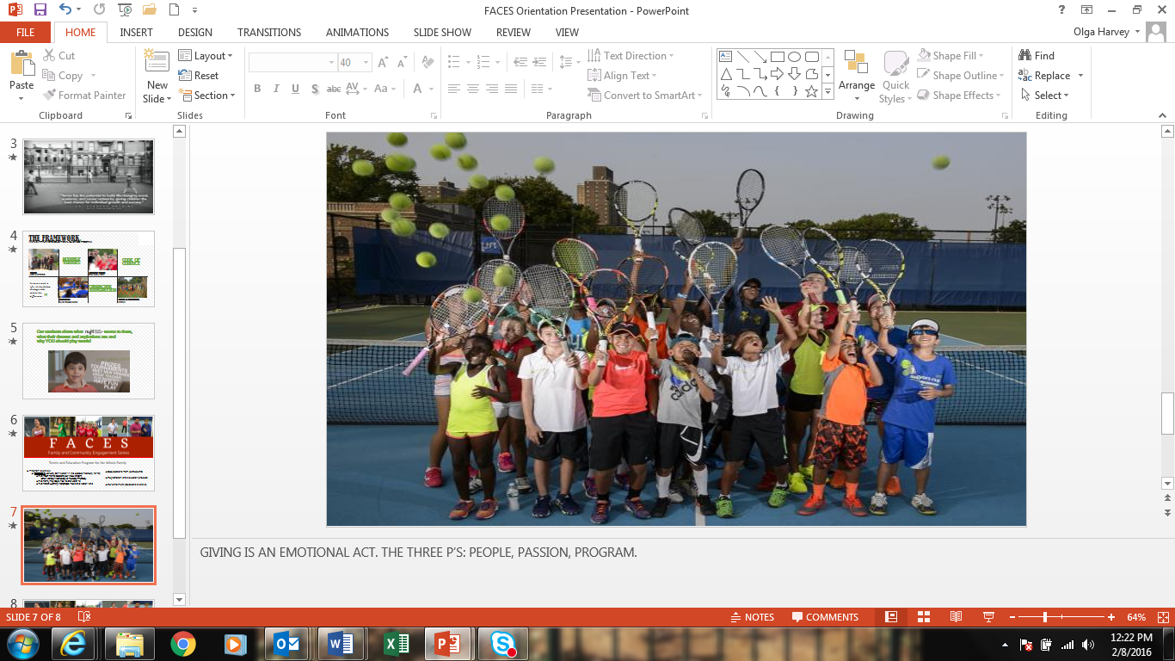

NYJTL’s mission is to develop the character of young people through tennis and education for a lifetime of success, both on and off the court. Through tennis, academic enrichment, healthy living and character development programs, NYJTL teaches life skills to 75,000 underserved K-12 youth at more than 80 sites in all five boroughs of New York City. NYJTL’s vision is to enable youth to grow with the game.

The NYJTL Cary Leeds Center for Tennis & Learning opened in 2015. The $26.5 million flagship home in the Bronx with 22 courts (10 covered in the winter), classrooms, and a clubhouse is open to the community providing 6,000 hours of free tennis and after school programs and activities.

**SUMMER GALA**

**at THE BOATHOUSE**

**AUGUST 2, 2017**



NYJTL’s Summer Gala is a major annual fundraising event held at the renowned Boathouse venue in Central Park.

The music, gondola rides, buffet dinner, silent auction, raffle, magicians, a tarot reader, and caricaturist, attract a crowd of over 500 young professionals for a win-win evening of fun and fundraising.

NYJTL guests also include New York City Council and State Legislature members, borough representatives, and corporate supporters.

Most importantly, the Summer Gala enables NYJTL to continue enriching the lives of our city’s youth through the character-building sport of tennis. All proceeds are directed to operating NYJTL’s year-round programs.