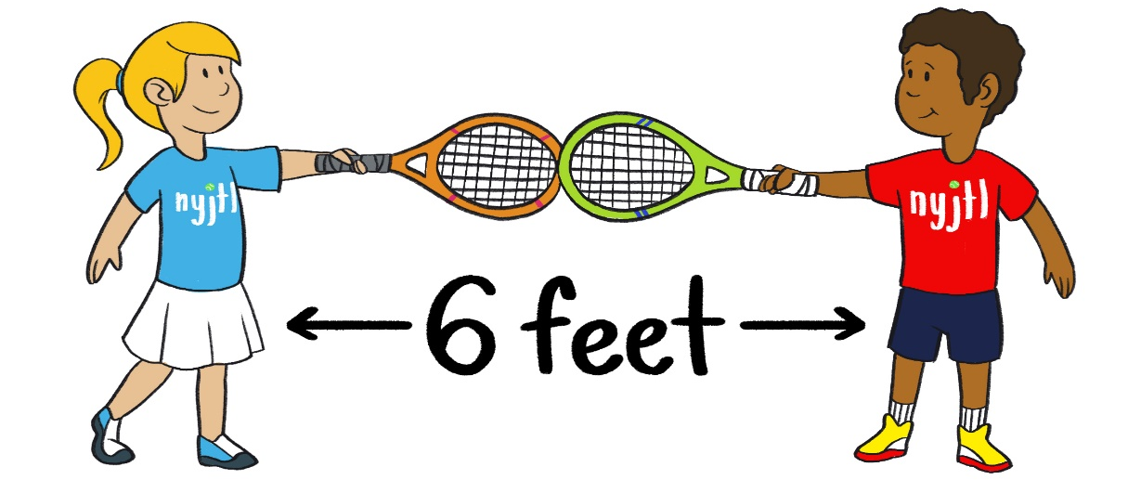

NYJTL Pandemic Rules

- Before entering the courts, all participants will have temperature taken and be asked 3 COVID Screening Questions
- Lessons by schedule only
- Online Registration for all participants – no scantrons to limit contact
- Arrive at courtside no earlier than 5 minutes ahead of your time. Check in and wait in the socially distanced line.
- Disperse immediately when your time is over.
- Sanitize your hands before entering the courts and immediately upon leaving.
- Wear a mask going to and coming off your court. You can remove it on court when your instructor says it’s okay.
- Wear a glove to pick up balls or pick them up in a no-touch way.
- Bring your own container of water.
- No snacks allowed.
- Bring your own racket if you have one. Do not share it with anyone else.
- Loaner rackets will be available
- Bring your own towel and you may also bring a mat or something to sit on. 10.Do not touch another person!
- Do not touch common equipment like cones or spots.
- Observe social distancing – keep 6 feet apart from everyone at all times.
- Tell your instructor right away if you feel at all sick. If you or anyone in your family gets sick while you are off the courts, you must call _____ right away, night or day!
- No parents are allowed on the courts. You must wait by the courtside if your child is 10 or under. Bring a chair. Socially distance. Wear a mask.

These rules will be strictly enforced, no exceptions!

