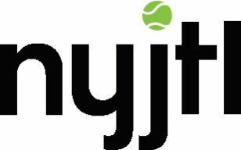

May 26, 2017

LETTER TO BE USED FOR “COLD CALLS”

Dear___________,

I am contacting you about an amazing organization that I am proud to support.

For 46 years, New York Junior Tennis & Learning (NYJTL) has provided underserved youth ages 5-18 a safe and nurturing after-school environment away from negative street culture. NYJTL offers tennis and educational services to more than 75,000 youth year-round at 80 sites in all five boroughs of New York City to help children reach their potential on the tennis court and in the classroom.

NYJTL’s Summer Gala will be held at the renowned Boathouse venue in Central Park on August 2. The music, gondola rides, buffet dinner, silent auction, raffle, magicians, a tarot reader, and caricaturist, attract a crowd of over 500 young professionals for a win-win evening of fun and fundraising.

As a Gala Committee member, I am writing to ask you to consider a donation for our silent auction.
_____ (Item Description) or another donation that you find appropriate will be most appreciated and will be well-received. Each auction item is described in the on-site display, Online Auction and in our Auction Journal, including a company logo and donor name recognition.

The description and picture of your donated item will reach our NYJTL network of over 20,000 supporters through social media, e-mail marketing and direct mail, 5,000 of which who are highly active.

In 2015, NYJTL opened the Cary Leeds Center for Tennis & Learning, its new $26.5 million flagship home in the Bronx consisting of 22 tennis courts and a community center. Now, more than ever, we need to continue fundraising efforts to provide much-needed operating support for 6,000 hours of free tennis for the community that NYJTL is offering annually at the Leeds Center.

In the words of our founder, Arthur Ashe, “We make a living by what we get, but we make a life by what we give.” We hope that you will support us.

Sincerely,

