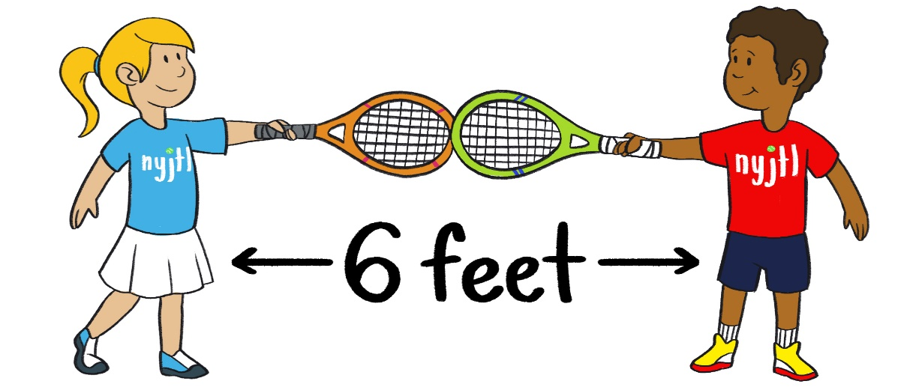

NYJTL - COVID Rules

- Before entering the courts, all participants will have temperature taken and be asked COVID Screening Questions
- Lessons by schedule only
- Depending on court availability, we encourage participants to Play on open courts while unsupervised by NYJTL staff
- Online Registration for all participants – no scantrons to limit contact
- Arrive at site on-time for full lesson (warm-up & drills)
- Kids are asked to leave lesson court after instruction is over – if courts are available, additional hitting is allowed with other participants
- Sanitize your hands before entering the courts and immediately upon leaving.
- Wearing a mask is optional
- BRING YOUR OWN CONTAINER OF WATER AND TOWEL.
- Bring your own racket if you have one.
- Loaner rackets are always available
- Bring your own towel and you may also bring a mat or something to sit on
- We recommend continued social distancing- Keep 6 feet
- Tell your instructor right away if you feel sick OR if anyone in your family gets sick.
- No parents are allowed on the courts. You must wait by the courtside if your child is 10 or under. Bring a chair. Socially distance. Wearing a mask is your option.

These rules will be strictly enforced, no exceptions!

