

**Free Community Tennis Program – Spring 2020 *Tentative / Subject to Change* v3 20 0221**

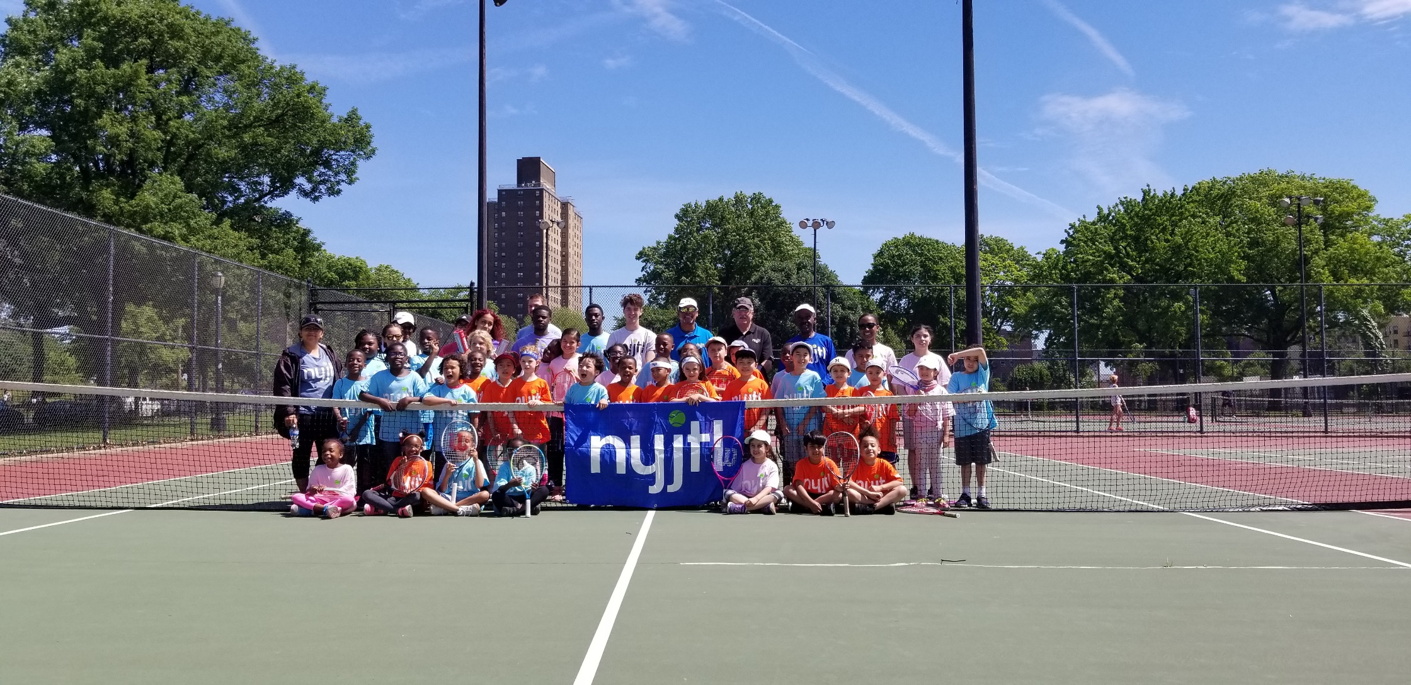

**BRONX (6)**

**Co-op City – Opens 4/27**

Tuesday – Friday: 3-6 pm  
Saturday 10am-1pm

Donizetti Place, Bx, NY 10475

Site Director: Ms. Lorraine  
CM King (12)

**Williamsbrige Oval – Opens 5/4**

Tuesday & Thursday, 3pm-6pm

3225 Reservoir Oval E,

Bronx, NY 10467

Site Director: TBD

CM Cohen (11)

**PS 306X – Opens 5/4  
Kids ages 5-10 ONLY**

Mon & Fri: 3-6pm,

40 W Tremont St,

Bronx, NY 10453

Site Director: Willie Green

CM Cabrera (14)

**Crotona Park – Opens 4/20**

Monday – Friday: 3-6 pm

1700 Crotona Ave, Bx, NY 10457

Site Director: Dudley Gayle

3 CMs (Gibson, Torres, Salamanca)

**BIYTC – Opens 5/4**

Tues-Fri: 3-6 pm, **Sat 9-12pm**  
754 Thieriot Ave,   
Bronx, NY 10473

Site Director: Alberto Luna

CM Diaz Sr. (18)

**St. James – Opens 5/2**Saturdays 10am-1pm

2600 Creston Avenue,

Bronx, NY 10468

Site Director: Willie Green

CM Cabrera (14)

**MANHATTAN (4)**

**Seward Park – Opens 5/4**

Mon, Wed & Fri, 3:30-6:30pm

Essex St & Hester St,  
New York, NY 10002

Site Director: Theodore S.

CM Chin (1)

**Octagon Park – Opens 5/4**

Mon, Wed, & Fri: 3-6 pm

**Starting 6/10 –M T W TH & F**

Roosevelt Island, NY 10044

Site Director: Joyce Short

CM Kallos (5)

**Howard Bennett – opens 5/5**

Tues, Wed & Thurs, 3-6pm

32 West 136th Street, NY, NY 10037  
Site Director: Marlene Charles

CM Perkins (9)

**PS 125M (Opens 5/9)**

Saturdays 10am-1pm  
[425 W123rd Street,   
New York, NY 10027](https://maps.google.com/?q=508+East+120+Street%2c+Manhattan%2c+NY+10035)

Site Director: Marlene Charles

CM Levine (7)

**PS 206 M (Opens 5/4)**

Monday & Friday 3-6 pm  
[508 East 120 Street,   
New York, NY 10035](https://maps.google.com/?q=508+East+120+Street%2c+Manhattan%2c+NY+10035)

Site Director: Marlene Charles

CM Ayala (8)

**Tentative Spring 2020 Locations**

**\*\*\*ALL SITES/TIMES Subject to Change\*\*\***

NYJTL's FREE Spring Tennis programs will start at a select number of locations late April with the remainder opening in early to Mid May. Most programs run Monday through Friday from 3pm – 6pm. Specific times and days may vary. Please check the location where you wish to participate to get the exact details.

For all NYJTL Community Tennis Programs, registration is OPEN. Players can register at any time during the season. Registration is completed in person ONLY during the program’s hours of operation.   
No online registrations. A reminder that this is not an application, it is a registration. So no one will be rejected or put on a waiting list. Attendance on any given day is optional.

Visit our website us at <http://www.nyjtl.org/programs/free-tennis/> for program updates

If you have questions or need additional information email [tc@nyjtl.org](mailto:tc@nyjtl.org) or   
call Alejandra at 347-417-8100 ext 105.

**Free Community Tennis Program – Spring 2020 *Subject to Change* v3 20 0221**



**BROOKLYN**

**PS 112K – Opens TBD**

**Kids ages 5-10 ONLY**  
Mon, Tues, &, Fri: 3-6 pm

7115 15th Avenue, Brooklyn, NY 11228  
Site Director: Curtis Blocker

CM Brennan (43)

**PS 229K – Opens TBD**

Monday & Tuesday, 3-6pm

14th Ave btwn Benson & Bath

Brooklyn, NY 11228

Site Director: Kareem King

CM Brennan (43)

**IS 240K/Andries – Opens TBD**

Mon, Wed & Fri: 3-6pm

2500 Nostrand Ave,   
Brooklyn, NY 11210

Site Director: Bob Spigner

CM Williams (45)

**McDonald Park – Opens TBD**

Mon, Wed & Fri: 3-6pm  
Saturday 10am-1pm

McDonald Ave btwn Ave S & T,

Brooklyn, NY 11223  
Site Director: Gennadiy Shuminov

CM Treyger (47)

**PS 197K – Opens TBD**

Tuesdays & Thursdays: 3-6pm

1599 E22nd Street,   
Brooklyn, NY 11210

Site Director: Gennadiy Shuminov

CM Deutsch (48)

**QUEENS**

**JHS 190Q – Opens TBD**

Monday – Friday: 3-6pm

68-17 Austin St,   
Forest Hills, NY 11375

Site Director: Gaetan Georges

CM Koslowitz (29)

**Juniper Valley Park – Opens TBD**  
Mon, Wed & Fri: 3-6pm

80th Street & Juniper Blvd S  
Middle Village, NY 11379

Site Director: Tom O’Kelly

CM Holden (30)

**Bayswater Park – Opens TBD**

Saturdays: 10am-1pm  
Bay 32nd St & Beach Channel Dr.

Far Rockaway, NY 11691

Site Director: Curtis B

CM Richards (31)

**BROOKLYN (9)**

**PS 123K – Opens TBD  
Students of PS 123K ONLY**

Wed & Thurs, 2:30pm – 5:30pm

100 Irving Avenue, Brooklyn, NY 11237  
Site Director: Curtis Blocker

CM Reynoso (34)

**Sperandeo Park @ 302 -Opens 5/4   
Sat. 10am-1pm**

Cleveland St. off Liberty Ave,  
Brooklyn, NY 11208  
Site Director: Athneal Phillip

CM Espinal (37)

**PS 133K – Opens TBD  
Kids ages 5-10 ONLY**Tuesday & Thursday, 3-6pm  
4th Ave & Baltic St, Brooklyn, NY 11217  
Site Director: Bob Spigner  
CM Lander (39)

**PS 219K – Opens TBD**

Mon, Wed & Fri: 3-6pm

1060 Clarkson Ave, Brooklyn, NY 11212

Site Director: Shay Lindo

CM Ampry-Samuel (41)

**Linden Park – Opens TBD**  
Monday – Thursday: 3-6 pm   
Saturday 10am-1pm

Vermont St. & Stanley Ave,

Brooklyn, NY 11207

Site Director: Hector Henry

CM Barron (42)

**QUEENS (9)**

**JHS 194Q – Opens TBD**

Tuesday & Thursday: 3-6pm  
**Saturday: 9am-12pm**

154-60 17 Ave, Whitestone, NY 11357  
Site Director: Joshua Basaldua

CM Vallone (19)

**Louis Pasteur Park - Opens TBD**  
**Saturdays 9 am - 1 pm**

248 St. bet. Van Zandt & 52 Ave.

Little Neck NY 11363  
Site Director: Tom O’Kelly

CM Vallone (19)

**Bay Terrace – Opens TBD**

Tuesday & Thursday

212-00 23rd Ave

Bayside, NY 11360

Site Director: Tom O’Kelly

CM Vallone (19)

**Cadwallader Playground – Opens TBD**

**Kids ages 5-10 ONLY**

**Monday, Wednesday & Friday**

31st Rd & Union St, Flushing, NY 11354

Site Director: Joshua Basaldua

CM Koo (20)

**PS 28Q – Opens TBD**

**Students of PS 28Q ONLY**

Tuesday – Friday: 3-6 pm

109-10 47 Ave, Corona, NY 11368

Site Director: Richard Jaklitsch

CM Moya (21)

**PS 205Q – Opens TBD**

Monday – Friday: 3-6pm

75-25 Bell Blvd, Bayside, NY 11364  
Site Director: Christian Georges

CM Grodenchik (23)

**STATEN ISLAND (2)**

**IS 2 – Opens 5/6**

Mon, Wed, & Fri: 3-6pm

333 Midland Avenue

Staten Island, NY 10306  
Site Director: Mike Akinola

CM Matteo (50)

**Silver Lake Park – Opens TBD**

Tuesday & Thursday: 3-6pm  
Saturday 10am-1pm

42 Revere Street

Staten Island, NY 10301  
Site Director: Mike Akinola

CM Rose (49)