

**Free Community Tennis Program – Spring 2019 *Subject to Change* v12 5/16/19**

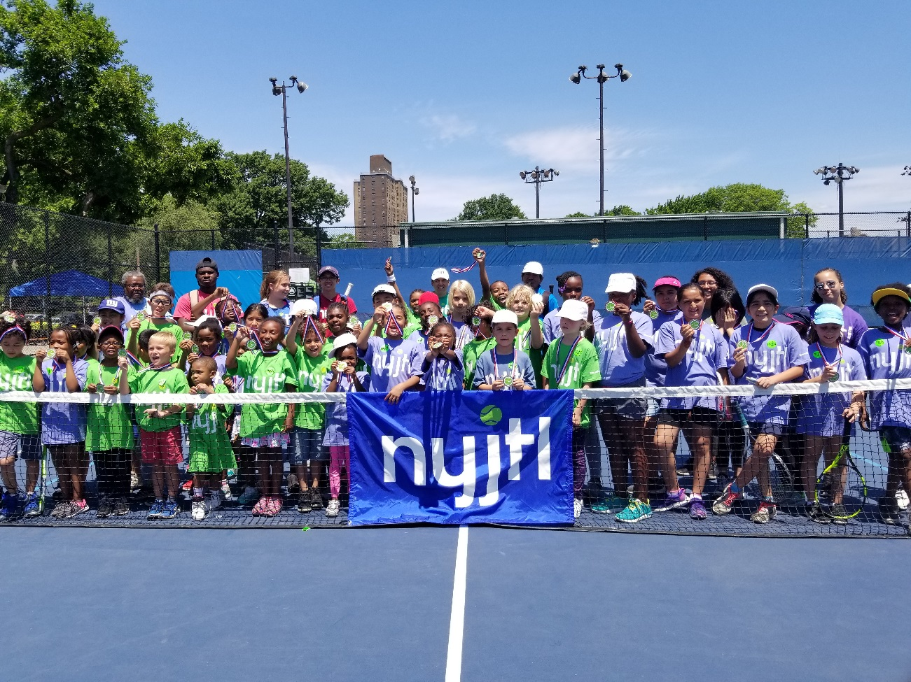

**BRONX (6)**

**Co-op City – Opens 4/29**

Monday – Friday: 3-6 pm

Donizetti Place, Bx, NY 10475

Site Director: Ms. Lorraine  
CM King (12)

**PS 14X – Opens 3/28 to 5/3**

Thursday & Friday: 2:30-5:30pm

3041 Bruckner Blvd  
Bronx, NY 10461

Site Director: Ms. Lorraine

CM Gjonaj (13)

**PS 306X – Opens 5/6   
Kids ages 5-10 ONLY**

Mon & Fri: 3-6pm, **Sat 9-12pm**

40 W Tremont St,

Bronx, NY 10453

Site Director: Willie Green

CM Cabrera (14)

**Crotona Park – Opens 4/22**

Monday – Friday: 3-6 pm

1700 Crotona Ave, Bx, NY 10457

Site Director: Eugene Bantovsky

3 CMs (Gibson, Torres, Salamanca)

**BIYTC – Opens 5/13**

Mon – Thurs: 3-6 pm, **Sat 9-12pm**  
754 Thieriot Ave,   
Bronx, NY 10473

Site Director: Alberto Luna

CM Diaz Sr. (18)

**MANHATTAN (5)**

**Seward Park – Opens 5/13**

Mon, Wed & Fri, 3:30-6:30pm

Essex St & Hester St,  
New York, NY 10002

Site Director: Theodore S.

CM Chin (1)

**Octagon Park – Opens 4/29**

Mon, Wed, & Fri: 3-6 pm

**Starting 6/10 –M T W TH & F**

Roosevelt Island, NY 10044

Site Director: Joyce Short

CM Kallos (5)

**Randalls Island – Opens TBD**

Saturdays 1pm-4pm

1 Randalls Island, NY, NY 10035  
Site Director: Ofir Solomon

CM Ayala (8)

**Howard Bennett – opens 5/7**

Tues, Wed & Thurs, 3-6pm

32 West 136th Street, NY, NY 10037  
Site Director: Marlene Charles

CM Perkins (9)

**Tentative Spring 2019 Locations**

**\*\*\*ALL SITES/TIMES Subject to Change\*\*\***

NYJTL's FREE Spring Tennis programs will start at a select number of locations on April 22, 2019 with the remainder opening on May 6 or 13. Most programs run Monday through Friday from 3pm – 6pm. Specific times and days may vary. Please check the location where you wish to participate to get the exact details.

For all NYJTL Community Tennis Programs, registration is OPEN. Players can register at any time during the season. Registration is completed in person ONLY during the program’s hours of operation.   
No online registrations. A reminder that this is not an application, it is a registration. So no one will be rejected or put on a waiting list. Attendance on any given day is optional.

Visit our website us at <http://www.nyjtl.org/programs/free-tennis/> for program updates

If you have questions or need additional information email [tc@nyjtl.org](mailto:tc@nyjtl.org) or   
call Alejandra at 347-417-8125 or Angela at 347-417-8153.



**Free Community Tennis Program – Spring 2019 *Subject to Change* v12 5/6/19**

**QUEENS**

**Cedar Grove – Opens 5/14**

**Kids ages 5-10 ONLY**

Tuesday & Friday, 3-6pm

Main St & Gravett Rd, Flushing NY 11367

Site Director: Samantha Ippolito

CM Lancman (24)

**JHS 190Q – Opens 5/6**

Monday – Friday: 3-6pm

68-17 Austin St,   
Forest Hills, NY 11375

Site Director: Gaetan Georges

CM Koslowitz (29)

**Juniper Valley Park – Opens 5/13**  
Mon, Wed & Fri: 3-6pm

80th Street & Juniper Blvd S  
Middle Village, NY 11379

Site Director: Tom O’Kelly

CM Holden (30)

**QUEENS (9)**

**JHS 194Q – Opens 5/13**

Monday, Wednesday, Friday: 3-6pm  
**Saturday: 9am-12pm**

154-60 17 Ave, Whitestone, NY 11357  
Site Director: Joshua Basaldua

CM Vallone (19)

**Louis Pasteur Park - Opens 5/11**  
**Saturdays 9 am - 1 pm**

248 St. bet. Van Zandt & 52 Ave.

Little Neck NY 11363  
Site Director: Tom O’Kelly

CM Vallone (19)

**PS 169Q – Opens 5/14**

**Students of PS 169Q ONLY**

Tuesday & Thursday, 3-6pm

18-25 212 St, Bayside, NY 11360

Site Director: Tom O’Kelly

CM Vallone (19)

**Cadwallader Playground – Opens 5/14**

**Kids ages 5-10 ONLY**

Tuesday & Thursday, 3-6pm

31st Rd & Union St, Flushing, NY 11354

Site Director: Joshua Basaldua

CM Koo (20)

**PS 28Q – Opens 5/14**

**Students of PS 28Q ONLY**

Tuesday – Friday: 3-6 pm

109-10 47 Ave, Corona, NY 11368

Site Director: Richard Jaklitsch

CM Moya (21)

**PS 205Q – Opens 4/29**

Monday – Friday: 3-6pm

75-25 Bell Blvd, Bayside, NY 11364  
Site Director: Christian Georges

CM Grodenchik (23)

**BROOKLYN (11)**

**PS 123K – Opens 5/15  
Students of PS 123K ONLY**

Wed & Thurs, 2:30pm – 5:30pm

100 Irving Avenue, Brooklyn, NY 11237  
Site Director: Curtis Blocker

CM Reynoso (34)

**Sperandeo Park @ 302  
Opens 5/4 - Sat. 9am-12pm**

Cleveland St. off Liberty Ave,  
Brooklyn, NY 11208  
Site Director: Athneal Phillip

CM Espinal (37)

**PS 133K – Opens 5/7  
Kids ages 5-10 ONLY**Tuesday & Thursday, 3-6pm  
4th Ave & Baltic St, Brooklyn, NY 11217  
Site Director: Bob Spigner  
CM Lander (39)

**PS 219K – Opens 5/6**

Mon, Wed & Fri: 3-6pm

1060 Clarkson Ave, Brooklyn, NY 11212

Site Director: Shay Lindo

CM Ampry-Samuel (41)

**Linden Park – Opens 4/29**  
Monday – Thursday: 3-6 pm

Vermont St. & Stanley Ave,

Brooklyn, NY 11207

Site Director: Hector Henry

CM Barron (42)

**PS 112K – Opens 5/6**

**Kids ages 5-10 ONLY**  
Mon, Tues, &, Fri: 3-6 pm

7115 15th Avenue, Brooklyn, NY 11228  
Site Director: Curtis Blocker

CM Brennan (43)

**BROOKLYN**

**PS 229K – Opens 5/13**

Monday & Tuesday, 3-6pm

14th Ave btwn Benson & Bath

Brooklyn, NY 11228

Site Director: Kareem King

CM Brennan (43)

**TAOTS ….**

**Academy of Talented Scholars   
Opens TBD**Days & Times TBD  
50 Avenue P, Brooklyn, NY 11204  
Site Director: Kareem King  
CM Yeger (44)

**IS 240K/Andries – Opens 5/6**

Mon, Wed & Fri: 3-6pm

2500 Nostrand Ave,   
Brooklyn, NY 11210

Site Director: Bob Spigner

CM Williams (45)

**McDonald Park – Opens 4/29**

Mon, Wed & Fri: 3-6pm

McDonald Ave btwn Ave S & T,

Brooklyn, NY 11223  
Site Director: Gennadiy Shuminov

CM Treyger (47)

**PS 197K – Opens 5/7**

Tuesdays & Thursdays: 3-6pm

1599 E22nd Street,   
Brooklyn, NY 11210

Site Director: Gennadiy Shuminov

CM Deutsch (48)

**STATEN ISLAND (2)**

**IS 2 – Opens 5/6**

Mon, Wed, & Fri: 3-6pm

333 Midland Avenue

Staten Island, NY 10306  
Site Director: Mike Akinola

CM Matteo (50)

**Silver Lake Park – Opens 5/7**

Tuesday & Thursday: 3-6pm

42 Revere Street

Staten Island, NY 10301  
Site Director: Mike Akinola

CM Rose (49)