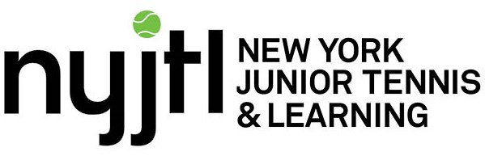

**FREE Community Tennis Program - Fall 2019   
Tentative and Subject to Change**

**Last Day of Programming: 10/19/2019 V1 8/15/19**

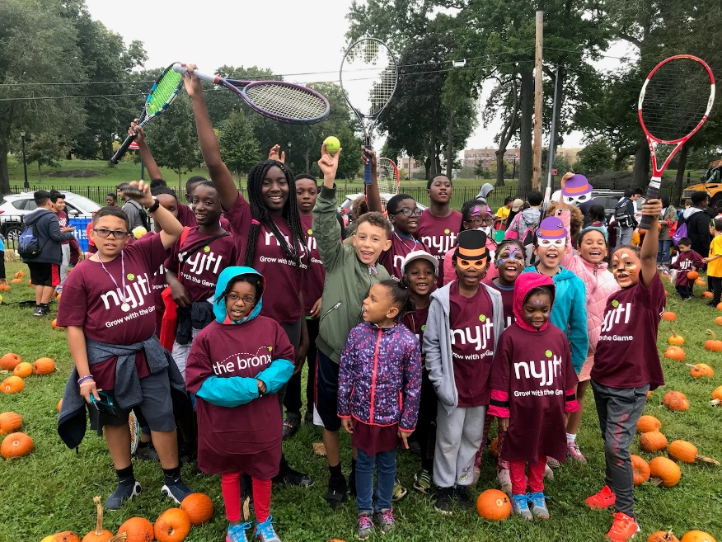

**QUEENS (cont.)**

**Forest Park (Opens 9/10)**

**Tues & Thurs, 3-6pm**

89-20 Park Ln S,

Woodhaven, NY 11421

**Site Director:** TBD  
**CM Holden (30)**

**Bayswater Park (Opens 9/9)**

**Mon, Wed, Fri, 3-6pm  
NEW Saturdays 9-12pm**

Bay 32nd St & Beach Channel Dr.

Far Rockaway, NY 11691

**Site Director:** Curtis B

**CM Richards (31)**

**Cadwallader Playground**

**(Opens 9/10)**

**Tues & Thurs 3-6pm**

31-15 140 Street,

Queens, NY 11354

**Site Director:** Joshua B

**CM Koo (20)**

**PS 223 (Opens 9/10)**

**Tues & Thurs 3-6pm**

125-20 Sutphin Boulevard,   
Queens, NY 11434

**Site Director:** Curtis B

**CM Adams (28)**

**Pomonok/Cedar Park (Open 9/10)**

**Tues & Thurs 3-6pm**

Kissena Blvd & 65th Avenue,

Flushing, NY, 11367

**Site Director: TBD**

**CM Lancman (24)**

**BROOKLYN (5)**

**Linden Park (Opens 9/10)**

**Tues - Fri 3-6pm**Vermont St & Stanley Ave

Brooklyn, NY 11207

**Site Director:** Hector Henry

**CM Barron (42)**

**PS 249K (Opens 9/9)**

**Mon, Wed, Fri, 3-6pm**

**Saturdays 9am- 12pm**

18 Marlborough Street

Brooklyn NY 11226

**Site Director:** Gennadiy S

**CM Eugene (40)**

**Jackie Robinson (Opens 9/9)**

**Mon, Wed, Fri, 3-6pm**

**Saturdays 9am- 12pm**

341 Malcolm X Boulevard

Brooklyn, NY 11233

**Site Director:** Bob S

**CM Cornegy (36)**

**Academy of Talented Scholars**

**(Opens 9/10)**

**Tues & Thurs 3-6pm**

50 Avenue P,

Brooklyn, NY 11204

**Site Director:** Gennadiy S.

**CM Yeger (44)**

**PS 9K (Opens 9/10)**

**Tues & Thurs 3-6pm**

80 Underhill Ave,

Brooklyn, NY 11238

**Site Director:** Bob S

**CM Cumbo (39)**

**QUEENS (10)**

**PS 169Q (Opens 9/10)  
Limited to PS 169Q**

**Tues & Thurs, 3-6pm**

18-25 212th Street

Bayside, NY 11360

**Site Director:** Tom O’Kelly

**CM Vallone (19)**

**JHS 194Q (Opens 9/9)**

**Mon, Wed, Fri, 3-6pm**

**NEW Saturdays, 9am-12pm**

17th Ave & Clintonville St.

Whitestone, NY 11357

**Site Director:** Joshua B

**CM Vallone (19)**

**Bay Terrace (Opens 9/9)**

**Mon, Wed, Fri, 3-6pm**

212-00 23rd Ave  
Bayside, NY 11360

**Site Director:** Tom O’Kelly

**CM Vallone (19)**

**PS 205Q (Opens 9/9)**

**Mon, Wed, Fri 3-6pm**

**NEW Saturdays 9am-12pm**

75-25 Bell Boulevard,   
Bayside, NY 11364

**Site Director:** Christian G

**CM Grodenchik (23)**

**JHS 190Q (Opens 9/9)**

**Mon, Wed, Fri, 3-6pm**

68-17 Austin St

Forest Hills, NY 11375

**Site Director:** Gaetan G

**CM Koslowitz (29)**

**For all NYJTL Community Tennis Programs,   
registration is OPEN.   
Players can come and register at any time   
during the season.   
Registration can be done in person ONLY during the program’s hours of operation.   
No online registrations.**

* **This is not an application, it is a registration.**
* **No one will be rejected.**
* **No one will be put on a waiting list.**
* **Attendance on any given day is optional.**

**Please feel free to visit our website-**[**http://www.nyjtl.org**](https://mail.nyjtl.org/owa/redir.aspx?C=2f0b6923a57146d19caab0cd3ee1c044&URL=http%3a%2f%2fwww.nyjtl.org)**/programs/free-tennis   
and for program updates and news.**

**Any questions?**

**Contact Scott Daly, Director, CTP at** [**tc@nyjtl.org**](mailto:tc@nyjtl.org)

**Or call: Alejandra 347-417-8125/   
Tiffany 347-417-8153**



**STATEN ISLAND (2)**

**Silver Lake Park (Opens 9/9)**

**Mon, Wed, Fri 3–6pm**

**Saturdays 9am- 12pm**42 Revere Street

Staten Island, NY 10301

**Site Director:** Mike Akinola

**CM Rose (49)**

**Wolfe’s Pond (Opens 9/9)**

**Tues & Thurs 3– 6pm**100 Luten Avenue,

Staten Island, 10312

**Site Director:** Mike Akinola

**CM Borelli (51)**

**BRONX (5)**

**Crotona Park (Opens 9/10)**

**Tues-Fri 3-6pm, Sat 9am-12pm**

1700 Crotona Avenue

Bronx, NY 10457

**Site Director:** Dudley Gayle

**CM Salamanca (17)**

**Williamsbridge Oval (Opens 9/9)**

**Mon, Wed, Fri, 3-6pm**

3225 Reservoir Oval E,

Bronx, NY 10467

**Site Director:** Alberto Luna

**CM Cohen (11)**

**Co-Op City (Opens 9/9)**

**Mon, Wed, Fri, 3-6pm,   
Saturdays 9-12pm**

Donizetti Place, Behind Truman HS,  
Bronx, NY 10475

**Site Director:** Ms. Lorraine

**CM King (12)**

**St. James (Opens 9/14)**

**Saturdays 9am-12pm**

2600 Creston Avenue,

Bronx, NY 10468

**Site Director:**

**CM Cabrera (14)**

**BIYTC (Opens 9/10)**

**Tues & Thurs, 3-6pm, Sat 9-12pm**

754 Thieriot Avenue,

Bronx, NY 10473

**Site Director:** Alberto Luna

**CM Rev. Diaz (18)**

**MANHATTAN (5)**

**PS 19M (Opens 9/11)  
Ages 10 & Under Only**

**Wed, Thurs, Fri 3-6pm**

11th St & 1st Ave

New York, NY 10003

**Site Director:** TBD

**CM Rivera (2)**

**PS 125M (Opens 9/9)**

**Mon, Wed, Fri 3-6pm**

**NEW Saturdays, 9am-12pm**

123rd St & Morningside Ave

New York, NY 10027

**Site Director:** Marlene Charles

**CM Levine (7)**

**PS 167M (Opens 9/9)**

**Monday & Tuesday, 3-6pm**

220 E 76th Street

New York, NY 10021

**Site Director:** TBD

**CM Powers (4)**

**Octagon Park (Opens 9/14)**

**NEW Saturdays 2-5pm**Main St (North End)

Roosevelt Island, NY 10044

**Site Director:** Joyce Short

**CM Kallos (5)**

**PS 206 M (Opens 9/10)**

**Tues & Thurs 3-6 pm**[508 East 120 Street, Manhattan, NY 10035](https://maps.google.com/?q=508+East+120+Street%2c+Manhattan%2c+NY+10035)

**Site Director:** Marlene Charles

**CM Ayala (8)**

**FREE Community Tennis Program - Fall 2019   
Tentative and Subject to Change**

**Last Day of Programming: 10/19/2019 V1 8/15/19**

**For all NYJTL Community Tennis Programs,   
registration is OPEN.   
Players can come and register at any time   
during the season.   
Registration can be done in person ONLY during the program’s hours of operation.   
No online registrations.**

* **This is not an application, it is a registration.**
* **No one will be rejected.**
* **No one will be put on a waiting list.**
* **Attendance on any given day is optional.**

**Please feel free to visit our website-**[**http://www.nyjtl.org**](https://mail.nyjtl.org/owa/redir.aspx?C=2f0b6923a57146d19caab0cd3ee1c044&URL=http%3a%2f%2fwww.nyjtl.org)**/programs/free-tennis   
and for program updates and news.**

**Any questions?**

**Contact Scott Daly, Director, CTP at** [**tc@nyjtl.org**](mailto:tc@nyjtl.org)

**Or call: Alejandra 347-417-8125/   
Tiffany 347-417-8153**