

V9 1/8/20

**FREE INDOOR TENNIS**

**Winter Weekend Indoor Program**

**2019-2020**

**Open to youth**

**ages 5 to 18**

**Starts November 2, 2019 Saturdays &/or Sundays**

**Various Locations**

**Citywide**

**For all NYJTL Community Tennis Programs, registration is OPEN.**

**Players can come and register at any time during the season.   
This is not an application, it is a registration.**

**No one will be rejected or put on a waiting list.**

**Registration can be done in person ONLY during the program’s hours of operation. No online registrations.**

**Attendance on any given day is optional.**

**ALL SITES CLOSED:**

**December 28th & 29th 2019 (New Year’s Weekend)  
February 22nd & 23rd, 2020   
Tennis resumes the weekend of January 4th & 5th, 2020  
and February 29th & March 1st, 2020**

**Last weekend of Instruction is March 14th & 15th, 2020   
Followed by 3 weekends of the Hartman Cup at Cary Leeds Center**

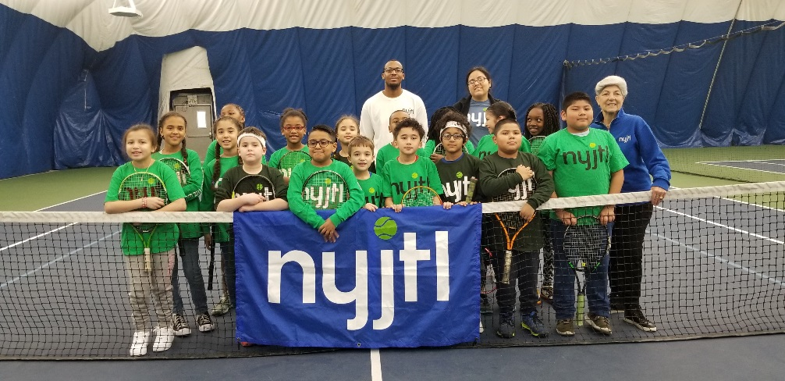

**For more information and a complete list of NYJTL Community Tennis Programs Visit** [**www.nyjtl.org/free-tennis**](http://www.nyjtl.org/free-tennis)**,   
email** [**tc@nyjtl.org**](mailto:tc@nyjtl.org) **or call 347-417-8177**

**Funded by the NYC Council   
 Hon. Melissa Mark-Viverito, Speaker**



**For more information and a complete list of NYJTL Community Tennis Programs   
Visit** [**www.nyjtl.org/programs/free-tennis**](http://www.nyjtl.org/programs/free-tennis)**,   
email** [**tc@nyjtl.org**](mailto:tc@nyjtl.org) **or call 347-417-8100 ext 105**

**BROOKLYN**

**Heights Casino**   
**Days:** Sundays ONLY

**Time:** 6am-8am

**Opens:** Sun 11/10

75 Montague Street

Brooklyn, NY 11201

**Site Director:** Gennadiy S.

**Match Point –   
Mill Basin**   
**Days:** Sundays ONLY  
**Time:** 6am-8am

**Opens:** Sun 11/10

2350 E 69th Street  
Brooklyn, NY   
**Site Director:** Colin C.  
  
**Match Point –   
Bensonhurst**   
**Days:** Saturdays ONLY  
**Time:** 7am-9am

**Opens:** Sat 11/9

9000 Bay Parkway  
Brooklyn, NY 11214  
**Site Director:** Kareem King

**MANHATTAN**

**Roosevelt Island Racquet Club**

**Days:** Saturdays & Sundays **Time:** 6am-8am **Open**s: Sat 11/9

281 Main Street

Roosevelt Island, NY 10044

**Site Director:** Joyce S.

**Manhattan Plaza**   
**Days:** Saturdays ONLY   
**Time:** 5:30am-7:30am

**Opens:** Sat 11/9  
450 West 43rd Street

Manhattan, NY 10036

**Site Directors:** Jake L.

**Jackie Robinson Center**   
**Days:** Saturdays ONLY **Time:** 12pm – 2pm

**Opens:** Sat 11/2  
85 Bradhurst Avenue

New York, NY 10039  
**Site Director:** Joyce S.

**BRONX**

**Cary Leeds Center**   
**Days:** Saturdays & Sundays

**Time:** 6am-8am

**Opens:** Sat 11/9

1720 Crotona Avenue

Bronx, NY 10457  
**Site Director:** Jeff L

**New York Tennis Club**

**Days:** Saturdays & Sundays

**Time:** 6am-8am

**Opens:** Sat 11/9

3081 Harding Avenue

Bronx NY, 10465

**Site Director:** Ms. Lorraine

**All Dates, Times & Locations are Subject to Change**

**QUEENS**

**USTA Billie Jean King NTC Days:** Saturdays & Sundays

**Time:** 6:30am-8am

**Opens:** Sat 11/9

National Tennis Center

Flushing, NY 11368

**Site Director:** Scott Daly

**Cunningham Tennis Center**

**Days:** Saturdays & Sundays

**Time:** 6am-7:45am

**Opens:** Sat 11/9

196-00 Union Turnpike

Fresh Meadows, NY 11365  
**Site Director:** Hector H.

**Bay Terrace Tennis Club  
CLOSED  
Days:** Sundays

**Time: 6-8am**

**‘19: Sun 11/10 to 12/1:** **10 & Under**  
**‘19-‘20: Sun 12/8 to 1/5: 11 & Up**212-00 23rd Ave,   
Bayside, NY 11360

**Site Director:** Tom O.

**New York Junior Tennis & Learning**

**58-12 Queens Boulevard, Ste 1**

**Woodside, NY 11377**

**Funded by the NYC Council   
 Hon. Corey Johnson  
 Speaker**