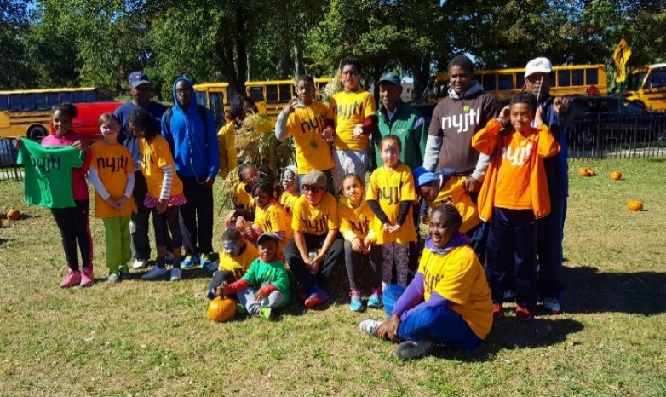

**MANHATTAN (3)**

**PS 19M (Opens 9/17)  
Ages 10 & Under Only**

**Mon, Wed, Fri 3-6pm**

11th St & 1st Ave

New York, NY 10003

**Site Director:** Theodore Small

**CM Rivera (2)**

**PS 125M (Opens 9/12)**

**Tues - Fri 3-6pm**

123rd St & Morningside Ave

New York, NY 10027

**Site Director:** Marlene Charles

**CM Levine (7)**

**PS 167M (Opens 9/24)**

**Monday & Tuesday, 3-6pm**

220 E 76th Street

New York, NY 10021

**Site Director:** Dudley G & Ron S

**CM Powers (4)**

**Octagon Park (Opens 9/15)**

**NEW Saturdays 2-5pm**Main St (North End)

Roosevelt Island, 10044

**Site Director:** Joyce Short

**CM Kallos (5)**

**BROOKLYN (3)**

**Linden Park (Opens 9/11)**

**Tues - Fri 3-6pm   
NEW Sundays 8:30-11:30am**

Vermont St &   
Stanley Ave

Brooklyn, NY 11207

**Site Director:** Hector Henry

**CM Barron (42)**

**PS 249K (Opens 9/12)**

**Tues - Fri 3-6pm**

18 Marlborough Street

Brooklyn NY 11226

**Site Director:** Gennadiy S

**CM Eugene (40)**

**Jackie Robinson (Opens 9/11)**

**Tues – Fri, 3-6pm**

341 Malcolm X Boulevard

Brooklyn, NY 11233

**Site Director:** Bob Spigner

**CM Cornegy (36)**

**STATEN ISLAND (2)**

**Silver Lake Park (Opens 9/10)**

**Mon, Thurs, Fri 3– 6pm**42 Revere Street

Staten Island, NY 10301

**Site Director:** Mike Akinola

**CM Rose (49)**

**Wolfe’s Pond (Opens 9/11)**

**Tues & Wed 3– 6pm**Cornelia Ave & Chester Ave

Staten Island, NY 10312

**Site Director:** Mike Akinola

**CM Borelli (51)**

**BRONX (6)**

**Crotona Park (Opens 9/11)**

**Tues-Fri 3-6pm,**

1700 Crotona Avenue

Bronx, NY 10457

**Site Director:** Eugene Bantovsky

**CM Salamanca (17)**

**Williamsbridge Oval (Opens 9/10)**

**Mon, Wed, Fri, 3-6pm**

3225 Reservoir Oval E,

Bronx, NY 10467

**Site Director:** Alberto Luna

**CM Cohen (11)**

**Co-Op City (Opens 9/10)**

**Mon, Wed, Fri, 3-6pm,   
NEW Saturdays 9-12pm**

Donizetti Place,

Behind Truman HS,  
Bronx, NY 10475

**Site Director:** Ms. Lorraine

**CM King (12)**

**PS 175X (Opens TBD)**

**Tues & Thurs, 3-6pm**

200 City Island Avenue

Bronx, NY 10464

**Site Director:** Ms. Lorraine

**CM Gjonaj (13)**

**PS 246X (Opens TBD)  
Tues & Thurs, 3-6pm**

2641 Grand Concourse,   
Bronx, NY 10468  
**Site Director:** Dudley Gayle

**CM Cabrera (14)**

**BIYTC (Opens 9/11)**

**Tues & Thurs, 3-6pm**

754 Thieriot Avenue,

Bronx, NY 10473

**Site Director:** Alberto Luna

**CM Rev. Diaz (18)**

**QUEENS**

**Forest Park (Opens 9/13)**

**Thurs & Fri, 3-6pm**

89-20 Park Ln S,

Woodhaven, NY 11421

**Site Director:** Jerry Tucker  
**CM Holden (30)**

**Bayswater Park   
(Opens 9/10)**

**Mon & Fri, 3-6pm  
NEW Saturdays 9-12pm**

Bay 32nd St &   
Beach Channel Dr.

Far Rockaway, NY

**Site Director:** Julian Morales

**CM Richards (31)**

**QUEENS (7)**

**PS 169Q (Opens 9/13)  
Limited to PS 169Q**

**Tues & Thurs, 3-6pm**

18-25 212th Street

Bayside, NY 11360

**Site Director:** Tom O’Kelly

**CM Vallone (19)**

**JHS 194Q (Opens 9/8)**

**NEW Saturdays, 9am-2pm**

17th Ave & Clintonville St.

Whitestone, NY 11357

**Site Director:** Jerry Tucker

**CM Vallone (19)**

**Bay Terrace   
(Opens 9/10)**

**Mon, Wed, Fri, 3-6pm**

212-00 23rd Ave  
Bayside, NY 11360

**Site Director:** Tom O’Kelly

**CM Vallone (19)**

**PS 205Q (Opens 9/12)**

**Mon, Tues, Wed, Fri 3-6pm**

75-25 Bell Boulevard,   
Bayside, NY 11364

**Site Director:** Christian Georges

**CM Grodenchik (23)**

**JHS 190Q (Opens 9/12)**

**Mon-Thurs 3-6pm**

68-17 Austin St

Forest Hills, NY 11375

**Site Director:** Gaetan Georges

**CM Koslowitz (29)**

**For all NYJTL   
Community Tennis Programs,   
registration is OPEN.   
Players can come and register at any time   
during the season.   
Registration can be done in person ONLY during the program’s hours of operation.   
No online registrations.**

* **This is not an application, it is a registration.**
* **No one will be rejected.**
* **No one will be put on a waiting list.**
* **Attendance on any given day is optional.**

**Please feel free to visit our website-**[**http://www.nyjtl.org**](https://mail.nyjtl.org/owa/redir.aspx?C=2f0b6923a57146d19caab0cd3ee1c044&URL=http%3a%2f%2fwww.nyjtl.org)**/programs/free-tennis   
and for program updates and news.**

**Any questions?**

**Contact Scott Daly, Director, CTP at** [**tc@nyjtl.org**](mailto:tc@nyjtl.org)

**Or call: Alejandra 347-417-8125/   
Angela 347-417-8153**

**FREE Community Tennis Program - Fall 2018   
Tentative and Subject to Change  
 Last Day of Programming: 10/21/2018 #8 0919**