

V7 12/21/18

**FREE INDOOR TENNIS**

**Winter Weekend Indoor Program**

**2018-2019**

**Open to youth**

**ages 5 to 18**

**Starts November 10, 2018 Saturdays &/or Sundays**

**Various Locations**

**Citywide**

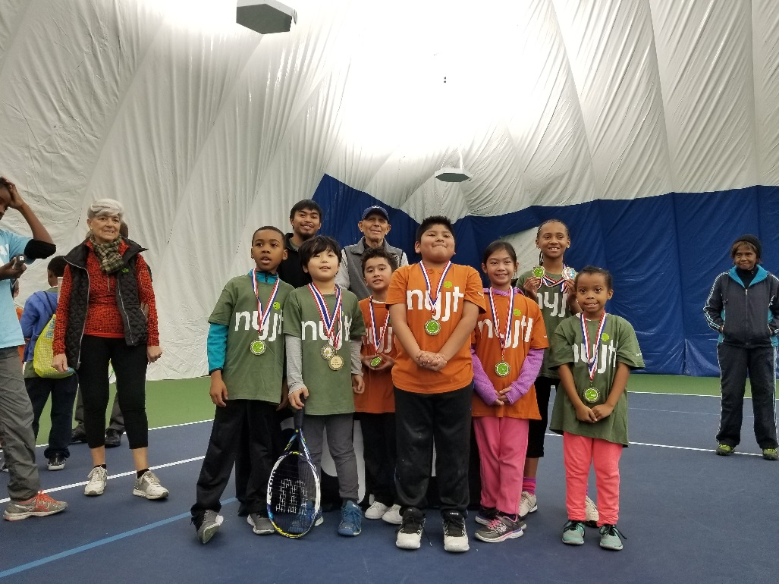

**For all NYJTL Community Tennis Programs, registration is OPEN.**

**Players can come and register at any time during the season.   
This is not an application, it is a registration.**

**No one will be rejected or put on a waiting list.**

**Registration can be done in person ONLY during the program’s hours of operation.**

**No online registrations.**

**Attendance on any given day is optional.**

**ALL SITES CLOSED:**

**December 29th & 30th 2018 (New Year’s Weekend)   
Tennis resumes the weekend of January 5th & 6th, 2019**

**Last weekend of Instruction is March 23rd & 24th, 2019   
Followed by 3 weekends of the Hartman Cup at the Cary Leeds Center**

**For more information and a complete list of NYJTL Community Tennis Programs Visit** [**www.nyjtl.org/free-tennis**](http://www.nyjtl.org/free-tennis)**,   
email** [**tc@nyjtl.org**](mailto:tc@nyjtl.org) **or call 347-417-8177**

**Funded by the NYC Council   
 Hon. Melissa Mark-Viverito, Speaker**



**MANHATTAN**

**Roosevelt Island Racquet Club**

**Days:** Saturdays & Sundays **Time:** 6am-8am **Open**s: Sat 11/10

281 Main Street

Roosevelt Island, NY 10044

**Site Director:** Joyce S.

**Manhattan Plaza**   
**Days:** Saturdays ONLY   
**Time:** 5:30am-7:30am

**Opens:** Sat 11/10   
450 West 43rd Street

Manhattan, NY 10036

**Site Directors:**   
Athneal P. & Jake L.

**BROOKLYN**

**Heights Casino**   
**Days:** Sundays ONLY

**Time:** 6am-8am

**Opens:** Sun 11/11

75 Montague Street

Brooklyn, NY 11201

**Site Director:** Gennadiy S.

**Match Point – Mill Basin**   
**Days:** Sundays ONLY **Time:** 6am-8am

**Opens:** Sun 11/11

2350 E 69th Street Brooklyn, NY 11234   
**Site Director:** Colin C.  
  
**PS 123K  
LIMITED to PS 123K kids**   
**Days:** TBD  
**Time:** 2:30pm-5:30pm

**Opens:** January 2019

100 Irving Ave,   
Brooklyn, NY 11237  
**Site Director:** Julian M.

**All Dates, Times & Locations are Subject to Change**

**BRONX**

**Cary Leeds Center**   
**Days:** Saturdays & Sundays

**Time:** 6am-8am

**Opens:** Sat 11/10

1720 Crotona Avenue

Bronx, NY 10457  
**Site Director:** Eugene B

**New York Tennis Club**

**Days:** Saturdays & Sundays

**Time:** 6am-8am

**Opens:** Sat 11/10

3081 Harding Avenue

Bronx NY, 10465

**Site Director:** Ms. Lorraine

**QUEENS**

**USTA Billie Jean King NTC Days:** Saturdays & Sundays

**Time:** 6:30am-8am

**Opens:** Sat 11/10

National Tennis Center

Flushing, NY 11368

**Site Director:** Scott Daly

**Cunningham Tennis Center**

**Days:** Saturdays & Sundays

**Time:** 6am-8am

**Opens:** Sat 11/10

196-00 Union Turnpike

Fresh Meadows, NY 11365  
**Site Director:** Hector H.

**Bay Terrace Tennis Club  
Ages 11 & Up ONLY**

**Days:** Sundays ONLY

**Time: 7:30am-9:30am NEW!**

212-00 23rd Ave,   
Bayside, NY 11360

**Open in 2019:** Sun 1/6 to 3/17

**Site Director:** Tom O.

**For more information and a complete list of NYJTL Community Tennis Programs Visit** [**www.nyjtl.org/programs/free-tennis**](http://www.nyjtl.org/programs/free-tennis)**,   
email** [**tc@nyjtl.org**](mailto:tc@nyjtl.org) **or call 347-417-8125**

**New York Junior Tennis & Learning**

**58-12 Queens Boulevard, Ste 1**

**Woodside, NY 11377**

**Funded by the NYC Council   
 Hon. Corey Johnson  
 Speaker**