**Free Community Tennis Program – Spring 2018 *Subject to Change* v8 5/9/18**



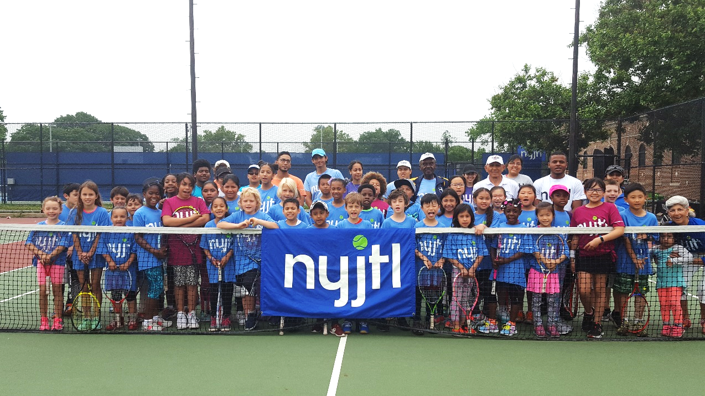

**MANHATTAN (4)**

**Octagon Park – Opens 4/30**

Monday, Wednesday &  
Friday: 3-6 pm

**Extended Hours 6/11 to End of Season**

Monday – Friday: 3-6pm

Main St (North End),   
Roosevelt Island, NY 10044

Site Director: Joyce Short

CM Kallos (5)

**Randalls Island – Opens 5/26**

Saturdays 1pm-4pm

1 Randalls Island, NY, NY 10035  
Site Director: Ofir Solomon

CM Ayala (8)

**PS 175M – Opens TBD**

Students of PS 175M ONLY

TBD

175 West 134 St, NY, NY 10030  
Site Director: Marlene Charles

CM Perkins (9)

**Howard Bennett – opens 5/8**

Tuesday, Wednesday, Thursday, 3-6pm

2 West 136th Street, NY, NY 10037  
Site Director: Marlene Charles

CM Perkins (9)

**BRONX (5)**

**Williamsbridge Oval – Opens 5/8**

Tuesday & Thursday, 3-6pm

3225 Reservoir Oval E,  
Bronx, NY 10467

Site Director: Willie Green

CM Cohen (11)

**Co-op City – Opens 4/23**

Monday – Friday: 3-6 pm

Donizetti Place, Bronx, NY 10475

Site Director: Lorraine Alexander

CM King (12)

**St. James Park – Opens 5/7**

Monday, Wednesday &   
Friday: 3-6 pm

Jerome Ave, E. 193 St, Creston Ave Bronx, NY 10468

Site Director: Dudley Gayle

CM Cabrera (14)

**Crotona Park – Opens 4/23**

Monday – Friday: 3-6 pm

1700 Crotona Ave,   
Bronx, NY 10457

Site Director: Eugene Bantovsky

3 CMs (Gibson, Torres, Salamanca)

**BIYTC – Opens 5/7**

Monday – Friday: 3-6 pm  
754 Thieriot Ave,   
Bronx, NY 10473

Site Director: Alberto Luna

CM Diaz Sr. (18)

**Tentative Spring 2018 Locations**

**\*\*\*ALL SITES/TIMES Subject to Change\*\*\***

NYJTL's FREE Spring Tennis programs will start at a select number of locations on April 23, 2018 with the remainder opening on May 7 or 14. Most programs run Monday through Friday from 3pm – 6pm. Specific times and days may vary. Please check the location where you wish to participate to get the exact details.

For all NYJTL Community Tennis Programs, registration is OPEN. Players can register at any time during the season. Registration is completed in person ONLY during the program’s hours of operation.   
No online registrations. A reminder that this is not an application, it is a registration. So no one will be rejected or put on a waiting list. Attendance on any given day is optional.

Visit our website us at <http://www.nyjtl.org/programs/free-tennis/> for program updates

If you have questions or need additional information email [tc@nyjtl.org](mailto:tc@nyjtl.org) or   
call Alejandra at 347-417-8125 or Angela at 347-417-8153.



**Free Community Tennis Program – Spring 2018 *Subject to Change* v8 5/9/18**

**BROOKLYN (12)**

**PS 257 – Opens 5/7**

Mondays & Thursdays: 3-6pm   
60 Cook Street

Brooklyn, NY 11206

Site Director: Kareem King

CM Reynoso (34)

**Sperandeo Park @ 302 – Opens 5/7**

Monday - Friday: 3-6 pm

Cleveland St. off Liberty Ave,

Brooklyn, NY 11208  
Site Director: Jackie Babb

CM Espinal (37)

**Park Slope School – Opens 5/12  
Closed 5/19, Resumes 5/26**Saturdays, 9am - 1pm  
**10 & Under Only**   
180 6th Avenue,  
Brooklyn, NY 11217  
Site Director: Gennadiy Shuminov  
CM Lander (39)

**BROOKLYN**

**PS 249K – Opens 5/8**  
Tuesdays & Thursdays: 3-6pm

18 Marlborough Road   
Brooklyn, NY 11226

Site Director: Bob Spigner

CM Eugene (40)

**PS 219K – Opens 5/7**

Monday, Wednesday, Friday:   
3pm -6pm

1060 Clarkson Avenue

Brooklyn, NY 11212

Site Director: Shay Lindo

CM Ampry-Samuel (41)

**Linden Park – Opens 4/23**  
Monday – Thursday: 3-6 pm

Vermont St. & Stanley Ave,

Brooklyn, NY 11207

Site Director: Hector Henry

CM Barron (42)

**PS 112K – Opens 5/8**  
Tuesday, Thursday &, Friday:   
3-6 pm

7115 15th Avenue

Brooklyn, NY 11206  
Site Director: Julian Morales

CM Brennan (43)

**PS 229K – Opens 5/8**  
Tuesday & Wednesday, 3-6pm

14th Ave btwn Benson & Bath

Brooklyn, NY 11228

Site Director: Kareem King

CM Brennan (43)

**QUEENS**

**Hallet’s Cove Playground – TBD**

Days & Times – TBD

30-01 Vernon Blvd,Astoria, NY 11102

Site Director: TBD

CM Constantinides (22)

**PS 205Q – Opens 4/23**

Monday – Friday: 3-6pm

75-25 Bell Blvd, Bayside, NY 11364  
Site Director: Christian Georges

CM Grodenchik (23)

**MS 172Q – Opens TBD**

Days & Times TBD

81-14 257th St, Glen Oaks, NY 11004

Site Director: TBD

CM Grodenchik (23)

**JHS 190Q – Opens 5/7**

Monday – Friday: 3-6pm

68-17 Austin St,   
Forest Hills, NY 11375

Site Director: Gaetan Georges

CM Koslowitz (29)

**Juniper Valley Park – Opens 5/14**  
Monday, Wednesday, Friday:   
3-6pm

80th Street & Juniper Blvd S  
Middle Village, NY 11379

Site Director: Tom O’Kelly

CM Holden (30)

**Bayswater Park – Opens 5/12**

Saturdays, 9am - 1pm

Bay 32nd St & Beach Channel Dr.

Far Rockaway, NY

Site Director: Julian Morales

CM Richards (31)

**QUEENS (9)**

**JHS 194Q – Opens 5/14**

Monday – Friday: 3-6pm

154-60 17 Ave, Whitestone, NY 11357  
Site Director: Joshua Basaldua

CM Vallone (19)

**Louis Pasteur Park - Opens 5/12**  
Saturdays 9 am - 1 pm

248 St. bet. Van Zandt & 52 Ave.

Little Neck NY 11363  
Site Director: Tom O’Kelly

CM Vallone (19)

**PS 169Q – Opens 5/15**

**Students of PS 169Q ONLY**

Tuesday & Thursday, 3-6pm

18-25 212 St, Bayside, NY 11360

Site Director: Tom O’Kelly

CM Vallone (19)

**Bay Terrace – Opens TBD**

Days & Times TBD

212-00 23rd Ave, Bayside NY 11360

Site Director: TBD

CM Vallone (19)

**PS 28Q – Opens 5/8**

**Students of PS 28Q ONLY**

Tuesday – Friday: 3-6 pm

109-10 47 Ave, Corona, NY 11368

Site Director: Richard Jaklitsch

CM Moya (21)

**IS 10 – Opens 5/21**   
Mon, Tues, Thurs, Fri, 3-6pm

45-11 31st Avenue, Queens, NY 11103

Site Director: Victor Santamaria

CM Constantinides (22)

**BROOKLYN**

**Col. David Marcus – opens 5/12**

Saturdays, 9am-1pm  
**10 & Under Only**

1662 E 5th Street

Brooklyn, NY 11230

Site Director: Kareem King

CM Yeger (44)

**IS 240K/Andries – Opens 5/7**

Monday, Wednesday, Friday:   
3-6pm

2500 Nostrand Avenue

Brooklyn, NY 11210

Site Director: Bob Spigner

CM Williams (45)

**McDonald Park – Opens 4/23**

Monday, Wednesday & Friday:   
3-6 pm

McDonald Ave btwn Ave S & T,

Brooklyn, NY 11223  
Site Director: Gennadiy Shuminov

CM Treyger (47)

**PS 197K – Opens 5/8**

Tuesdays & Thursdays: 3-6pm 1599 E22nd Street

Brooklyn, NY 11229

Site Director: Gennadiy Shuminov

CM Deutsch (48)

**STATEN ISLAND (2)**

**IS 2 – Opens 5/7**

Mon, Wed, & Fri: 3-6pm

333 Midland Avenue

Staten Island, NY 10306  
Site Director: Mike Akinola

CM Matteo (50)

**Silver Lake Park – Opens 5/8**

Tuesday & Thursday: 3-6pm

42 Revere Street

Staten Island, NY 10301  
Site Director: Mike Akinola

CM Rose (49)